**AIF SetUp , Debug and Tips**

**Set up**: AIF is a separate component in AX 2009 Installation media and most probably you may not have installed AIF during your initial AX set-up.

**Pre-req for AIF is IIS and Asp.net (if you already have these on your VM skip to next step), IIS and Asp.Net installation**:

1. Server Manager -> Add Roles
2. On select Server Roles screen -> select Web Server (IIS)
3. It may prompt you to add features required for Web server (IIS) -> click Add required features

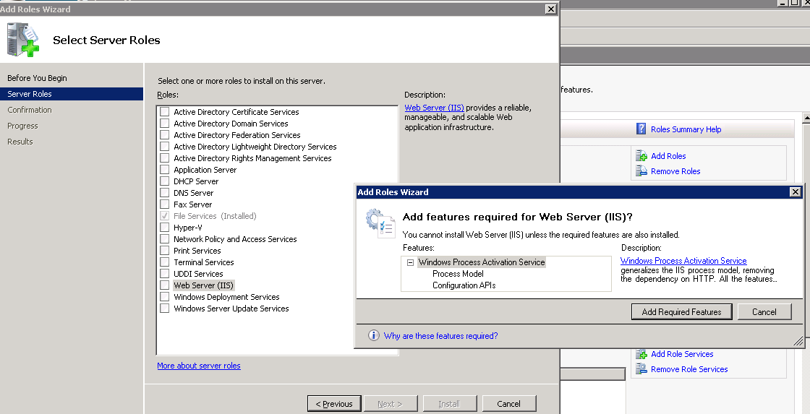

1. Click next until you hit “Select Role Services” screen -> Select Asp.Net (under Application Development)
2. It may prompt you for “ Add role services and features required for ASP.NET” –> then click on “Add Required Role Services” button and click next:

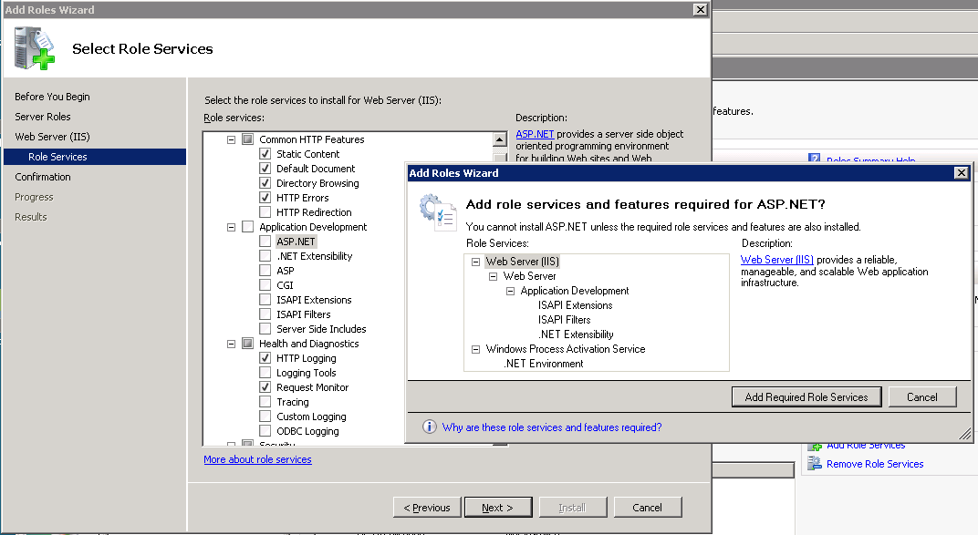

1. On Select Role services screen , select these elements too:
2. Security -> Basic Authentication
3. Security -> Windows Authentication
4. Management Tools -> Management Service
5. Management Tools -> IIS 6 Management Compatibility
6. Click next and Install the components selected so far (Windows OS components)
7. Just to be safe restart the machine
8. Verify that you have IIS installed by opening IIS Manager
9. You may need to register ASP.Net with IIS : search online to see how to do that
10. You may need to register wcf service with IIS: search online to see how to do that

**AIF Set up**:

1. Prereq – Update BC Proxy account:

AX -> admin -> SetUp -> Security -> System Service accounts -> Business Connector Proxy -> “msdyn-dev-bcp”

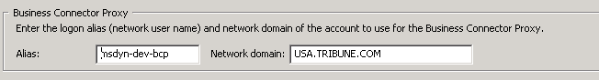

1. To check if you have AIF installed or not and install the necessary components -

Run the AX 2009 installation media -> select Add or modify Components

1. On the Add or Modify components screen , notice if any these components are greyed out:

AIF Web services

.Net Business Connector

Debugger

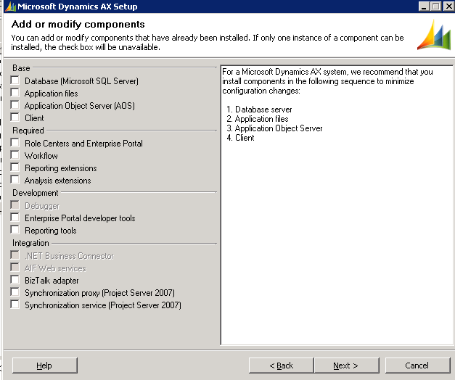

1. If these components are greyed out then it means you already them installed.

Install the components that are not greyed out (AIF Web services, .Net Business Connector, Debugger)

1. Now you should have installed IIS, Asp.Net, AIF , .Net BC, Debugger
2. At this point your IIS should have AIF as a child website under default website:

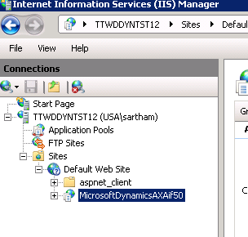

1. Make sure you have run the scrubber on AX DB
2. Configure the website : Basic -> set Up -> Application Integration framework -> websites
3. If You do not have a record like this, then create one that points to:

\\<Your Machine Name>\ MicrosoftDynamicsAXAif50

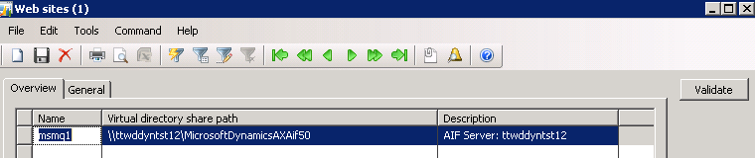

1. Click validate and see it doesn’t any error (if error you may have to debug and fix the problem)

**Generate service definition and schema**:

1. Open services form : Basic -> Set up -> AIF -> Services
2. On services screen sort the records by “Enabled” column so we can see the enabled services on the top
3. Click Refresh button (this one just scans the AOT for all services and updates this screen in case any of the services are missing)

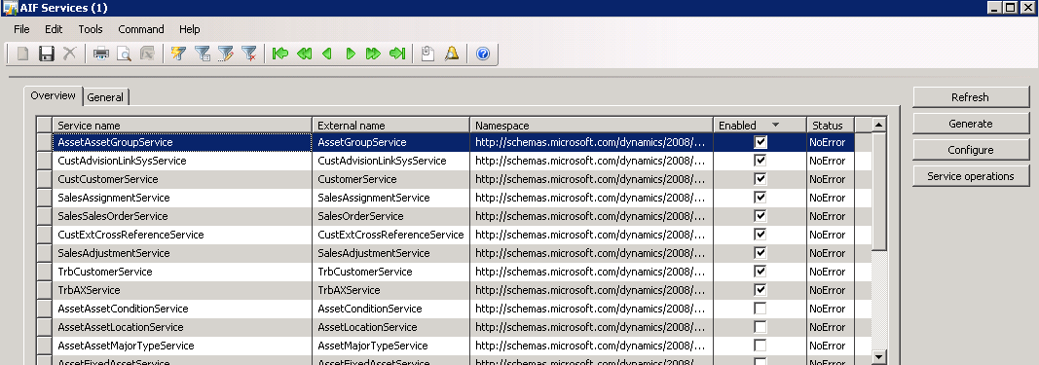

1. Click Generate button, this will generate all the service definition and schema files to :

C:\Program Files\Microsoft Dynamics AX\50\AifWebServices

Or

\\<Your Machine Name>\ MicrosoftDynamicsAXAif50

(both the paths are one and same)

1. The bindings and other settings in your generated web.config(C:\Program Files\Microsoft Dynamics AX\50\AifWebServices) might differ from QA. So you can copy the web.config from QA and replace the one on your VM

**Testing your services using Smoke Test tool**:

1. Copy these 2 files to your VM (into some directory, of course both should be in the same directory)

\\xen02\AXFiles\AIF Smoke Test\QA1 LB\AIFTest.exe

\\xen02\AXFiles\AIF Smoke Test\QA1 LB\AIFTest.exe.config

1. Update your local config file:

* Open config file to edit (AIFTest.exe.config) – VS is better choice since you get intellisense
* Within this config file notice that all the <endpoint> elements address would point to “axaifqa.tribune.com”. Replace “axaifqa” with your VM name

1. Run the AifTest.exe on your VM and make sure tests pass against your VM(Customer, SalesOrder, Adjustment)

**Debug AIF using File System Adapter**:

1. To set-up File System Adapter follow this existing document - [setupAIFFileAdapter](http://teams.tribune.com/projects/Project%20Engine/Project%20Documents/Technical%20Specifications/AX/03-Development/setupAIFFileAdapter%20(2).docx)
2. You would need to place this file in your AIF directory (C:\AIF)

* Create a new file with name “updateInboundOwner.bat”
* Paste this script in the file

ICACLS C:\AIF\Inbound\*.* /setowner USA\<your user name>

1. Now let’s verify that a SOAP request placed in “C:\AIF\Inbound” is picked up by AIF, processes it and places the output file in C:\AIF\Outbound. We will do this with Customer creation request.
2. Place this customer create request file in the inbound folder “C:\AIF\Inbound”

Name of the customer in this request file - “Test AIF File System Adapter1”



1. Run this job in AX “runAIFReceive_and_Send”. Now AIF should pick the request , process it (create customer) and place the output in C:\AIF\Outbound.
2. If successfully finished the output file would contain the Account number of the newly created Customer. You can verify that customer name and account number matches from Customer screen. Customer create Output file would be like this:



1. Debugging – To be able to debug while AIF processes the requests you would need to update native AIF class - AifInboundProcessingService. Let’s do it now:

* Back up the class AifInboundProcessingService by exporting it
* Update the class AifInboundProcessingService by importing this file:



1. Example of debugging: During the customer creation this method will be called

AxdCustomer.prepareForSave(AxdStack _axdStack, str _dataSourceName).

* Put a breakpoint in this method
* Place a new customerCreate.xml in inbound folder(update the customer name)
* Run the job “runAIFReceive_and_Send” and you should hit the breakpoint in method AxdCustomer. prepareForSave().

1. Similarly to debug SalesOrder service, you can put a breakpoint in method AxdSalesOrder. prepareForSave().

1. More sample messages:









1. All the AIF logs are recorded here(Company specific) :

Basic -> Periodic -> Application Integration Framework ->

Document History – All AIF requests and responses are recorded here

Exceptions – All AIF errors are recorded here

1. Sql to search AX database for all the requests and responses related to a particular proposal number:

select B.CREATEDDATETIME, A.CREATEDDATETIME, A.MESSAGEID, A.DATAAREAID, A.RECID, A.DOCUMENTXML , B.ACTIONID, B.SOURCEENDPOINTID

from [dbo].[AIFDOCUMENTLOG] A

inner join dbo.AIFMESSAGELOG B on A.MESSAGEID = B.MESSAGEID

where

A.DOCUMENTXML like '%2087296%'

and (B.CREATEDDATETIME between '1/27/2014' and '1/28/2014')

order by B.CREATEDDATETIME asc